Imagine IT (Information Technology) as the behind-the-scenes magic that makes all our electronic devices work together. It's like a giant toolbox filled with tools to manage information. These tools include computers, of course, but also things like phones, tablets, printers, and even the internet itself!

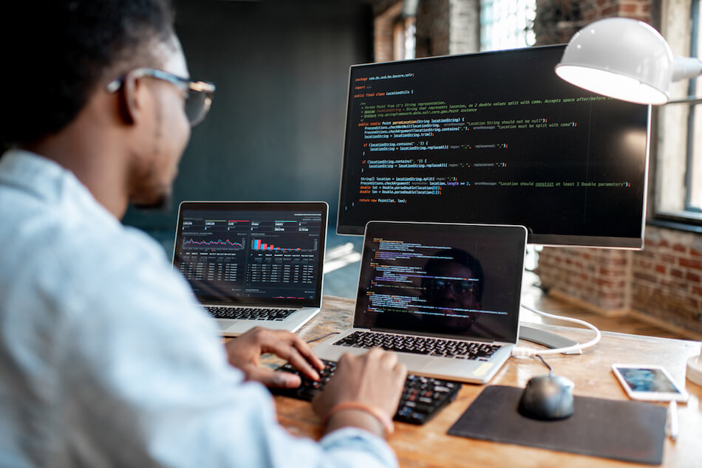

IT people use these tools to keep everything running smoothly. They make sure our computers are safe from bad guys, that our printers can print, and that we can connect to the internet to chat with friends or watch videos. They're also like doctors for our devices, fixing problems when things go wrong and helping us learn how to use all the cool features.

So next time you use your computer, phone, or any other electronic device, remember the IT people working behind the scenes to make it all possible! They're the ones keeping the information flowing and making sure we can stay connected in today's digital world.